RESULT GTM TAG IN STG

1. **ToU & PP Viewed**

Note :

* Event_Name = Tou_agreed
* Done Implement

1. **ToU & PP Agreed**

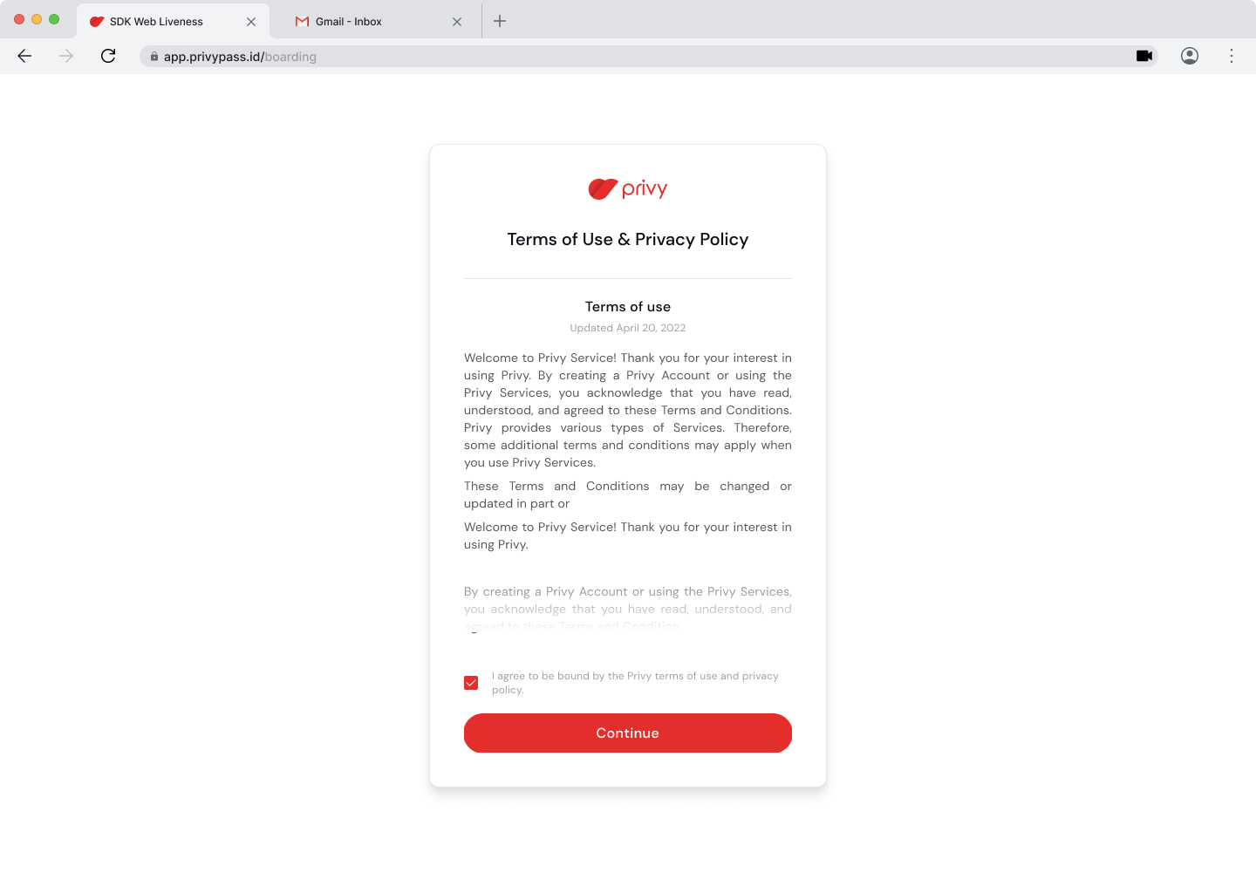

Note :

* Event_Name = Contact_info_viewed
* Done Implement

1. **Contact Info Viewed**

Note :

* Event_Name = contact_info_viewed
* Perlu adanya URL yang beda, path, atau # dengan tujuan pembeda tiap page

1. **Contact Info Submitted**

Note :

* Event_Name = contact_info_submitted
* Done Implement

1. OTP Email Viewed

Note :

* Event_Name = otp_email_viewed
* Perlu adanya URL yang beda, path, atau # dengan tujuan pembeda tiap page

1. OTP Email Succeed

Note :

* Event_Name = otp_email_succeed
* Perlu adanya tombol untuk bisa di track eventnya

1. OTP Phone Viewed

Note :

* Event_Name = otp_phone_viewed
* Perlu adanya URL yang beda, path, atau # dengan tujuan pembeda tiap page

1. OTP Phone Succeed

Note :

* Event_Name = otp_phone_succeed
* Perlu adanya tombol untuk bisa di track eventnya

1. Select Citizenship Viewed

Note :

* Event_Name = citizenship_viewed
* Perlu adanya URL yang beda, path, atau # dengan tujuan pembeda tiap page

1. Indonesian Selected

Note :

* Event_Name = indonesian_selected
* Done Implement

1. Onboard OCR Viewed

Note :

* Event_Name = onboard_ktp_wni_viewed
* Perlu adanya URL yang beda, path, atau # dengan tujuan pembeda tiap page

1. OCR Continued

Note :

* Event_Name = onboard_ktp_wni_continue
* Done Implement

1. Personal Info Viewed

Note :

* Event_Name = personal_data_viewed
* Perlu adanya URL yang beda, path, atau # dengan tujuan pembeda tiap page

1. Personal Data Confirmed

Note :

* Event_Name = personal_data_confirmed
* Done Implement

1. Onboard Liveness Viewed

Note :

* Event_Name = onboard_liveness_viewed
* Perlu adanya URL yang beda, path, atau # dengan tujuan pembeda tiap page

1. Liveness Continued

Note :

* Event_Name = liveness_continued
* Done Implement

1. Liveness Succeed

Note :

* Event_Name = liveness_succeed
* Done Implement